W205 Lab 9

Cynthia Hu

7/22/2017

1. What is the shortest path between 'DR. STRANGE/STEPHEN' and 'DR. DOOM/VICTOR VON'?

Please provide: the query, the Text side tab results of running the query, and the answer.

**Query:**

MATCH p=(stephen:Hero {name: 'DR. STRANGE/STEPHEN' })-[:APPEARED*0..2]-(victor:Hero {name: 'DR. DOOM/VICTOR VON'})

RETURN p, length(p)

ORDER BY length(p)

LIMIT 2

**Tab Results:**

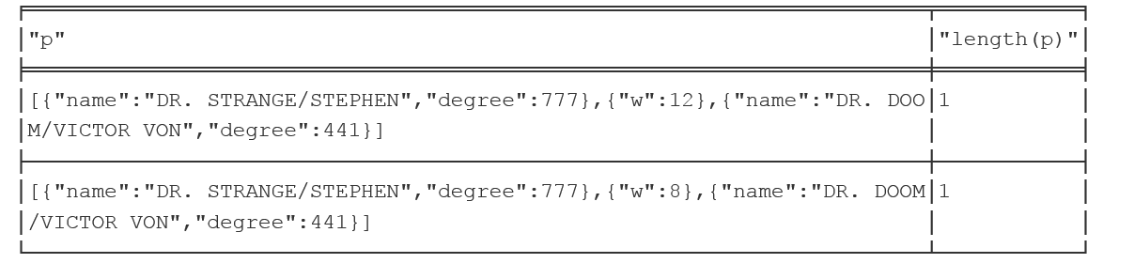

**Answer:**

Shortest path is length 1.

1. List the 5 shortest paths between 'DR. STRANGE/STEPHEN' and 'DR. DOOM/VICTOR VON'.

Please provide: the query and the Text side tab results of running the query.  
Only provide 5 even if there are ties (hint: use the LIMIT 5 clause in the query).

**Query:**

MATCH p=(stephen:Hero {name: 'DR. STRANGE/STEPHEN' })-[:APPEARED*0..2]-(victor:Hero {name: 'DR. DOOM/VICTOR VON'})

RETURN p, length(p)

ORDER BY length(p)

LIMIT 5

**Tab Results:**

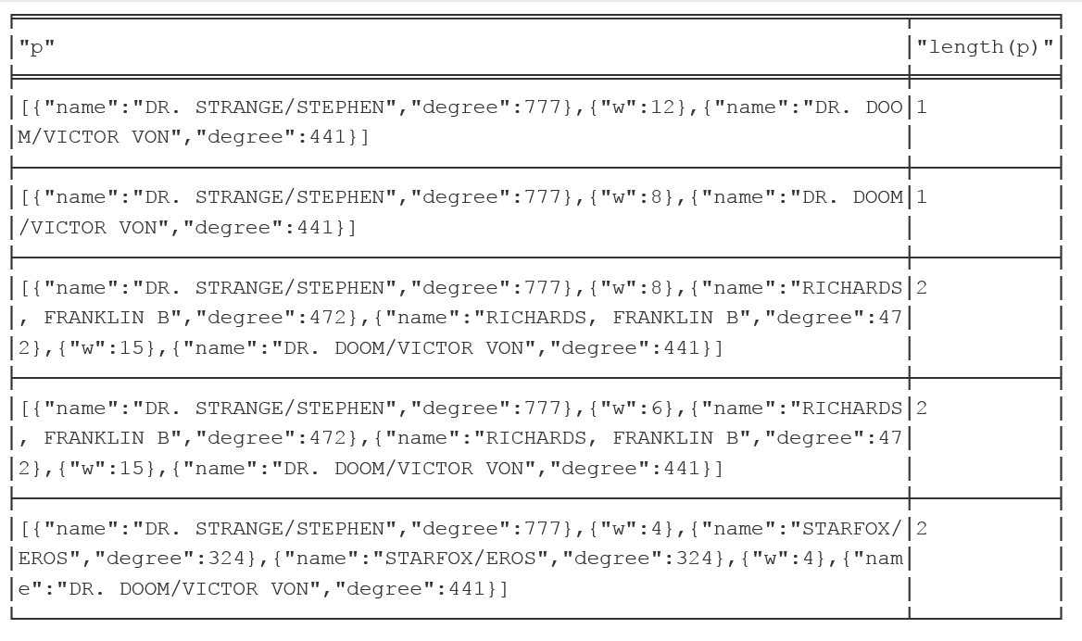

1. List 5 Friends of Friends of 'COLOSSUS II/PETER RA' with the most connections.

Please provide: the query and the Text side tab results of running the query.  
Only provide 5 even if there are ties (hint: use the LIMIT 5 clause in the query)

**Query:**

MATCH (peter:Hero { name: 'COLOSSUS II/PETER RA' })-[:APPEARED*2..2]-(friend_of_friend)

WHERE NOT (peter)-[:APPEARED]-(friend_of_friend)

AND friend_of_friend.name <> 'COLOSSUS II/PETER RA'

RETURN friend_of_friend.name, COUNT(*)

ORDER BY COUNT(*) DESC , friend_of_friend.name

Limit 5

**Tab Results:**

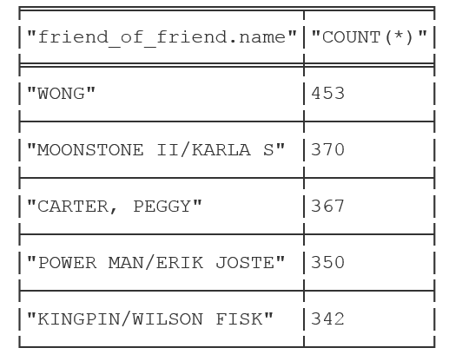

1. Visualize 10 Friends of friends for 'IRON MAN/TONY STARK'.

Please provide: the query and an image of the graph visualization. Only provide 10 even if there are ties (hint: use the LIMIT 10 clause in the query)

**Query:**

MATCH (tony:Hero { name: 'IRON MAN/TONY STARK'})-[:APPEARED*2..2]-(friend_of_friend)

WHERE NOT (tony)-[:APPEARED]-(friend_of_friend)

AND friend_of_friend.name <> 'IRON MAN/TONY STARK'

RETURN friend_of_friend

LIMIT 10

**Graph:**

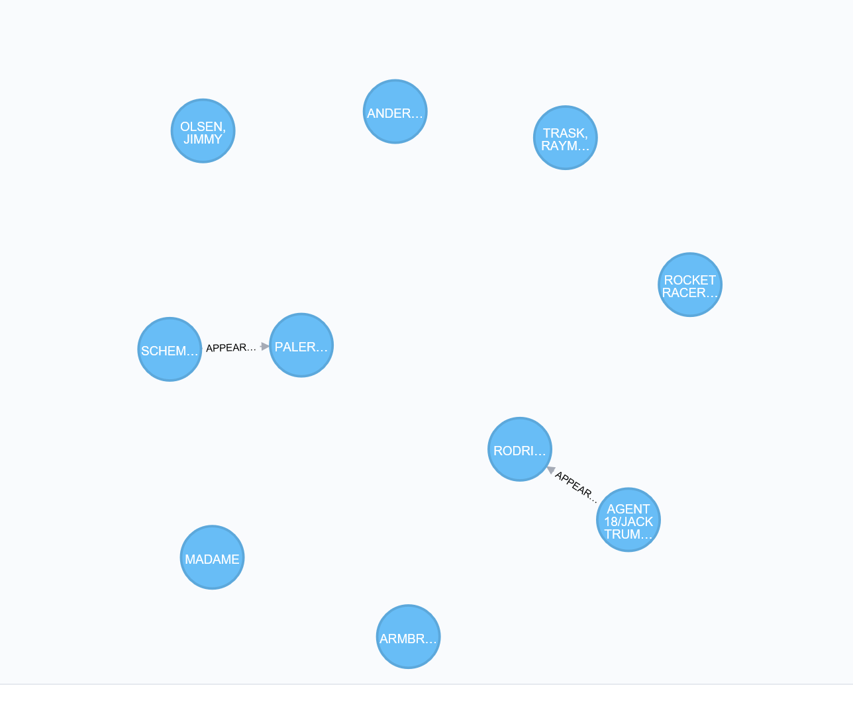

1. Visually discover how the Avengers grew over time from 5 to 10 members, who was added to the team, and verify connectivity.

Please provide for each run of the query (6 total runs): The query, a list of member for this run, a statement as to whether or not the graph is fully connected, and the an image of the graph visualization

1. 5 members

**Query:**

MATCH (tony:Hero {name:'IRON MAN/TONY STARK'}) -[e:APPEARED]-> (other) <-[f:APPEARED]- (donald:Hero {name:'THOR/DR. DONALD BLAK'})

RETURN tony, donald, other

ORDER BY e.w DESC, f.w DESC

LIMIT 3

**Members:**

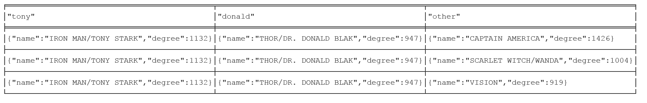

**Graph**: It’s a connected graph. 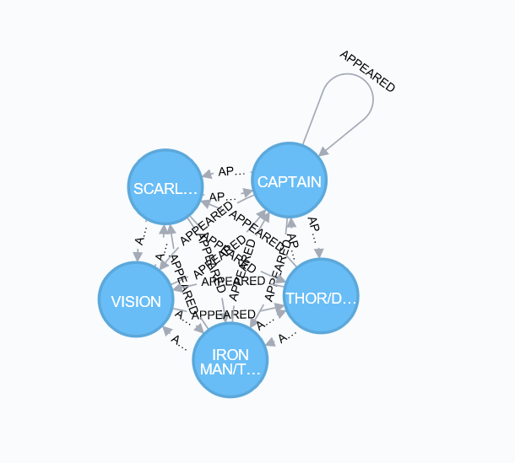

1. 6 members

**Query:**

MATCH (tony:Hero {name:'IRON MAN/TONY STARK'}) -[e:APPEARED]-> (other) <-[f:APPEARED]- (donald:Hero {name:'THOR/DR. DONALD BLAK'})

RETURN tony, donald, other

ORDER BY e.w DESC, f.w DESC

LIMIT 4

**Members:**

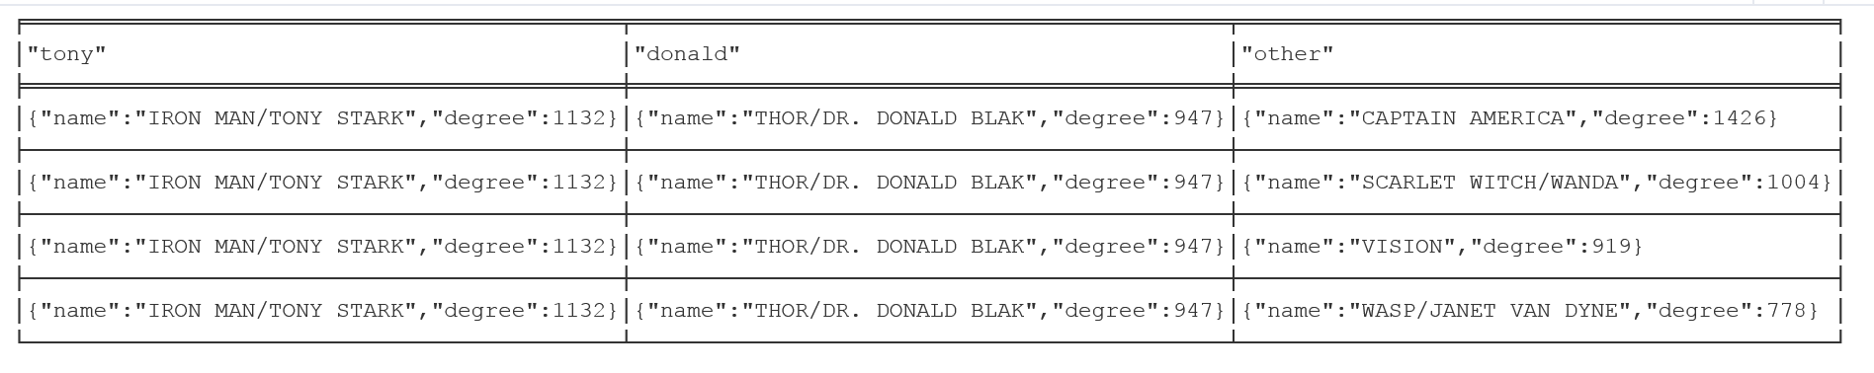

**Graph: it’s a connected graph**.

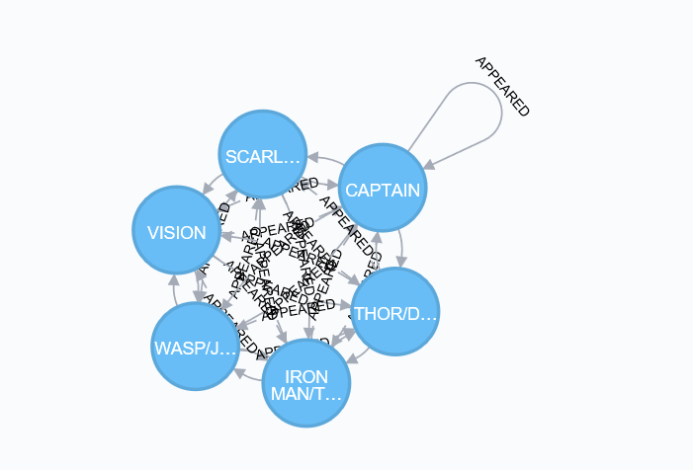

1. 7 members

**Query:**

MATCH (tony:Hero {name:'IRON MAN/TONY STARK'}) -[e:APPEARED]-> (other) <-[f:APPEARED]- (donald:Hero {name:'THOR/DR. DONALD BLAK'})

RETURN tony, donald, other

ORDER BY e.w DESC, f.w DESC

LIMIT 5

**Members:**

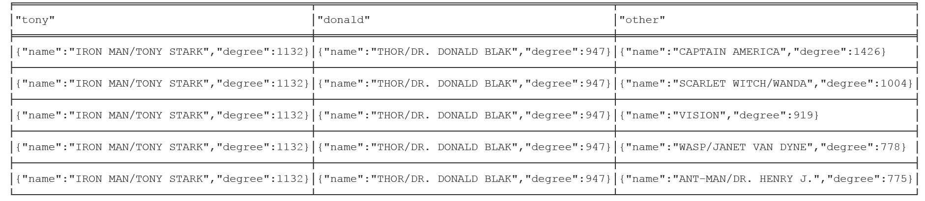

**Graph**: It’s a connected graph.

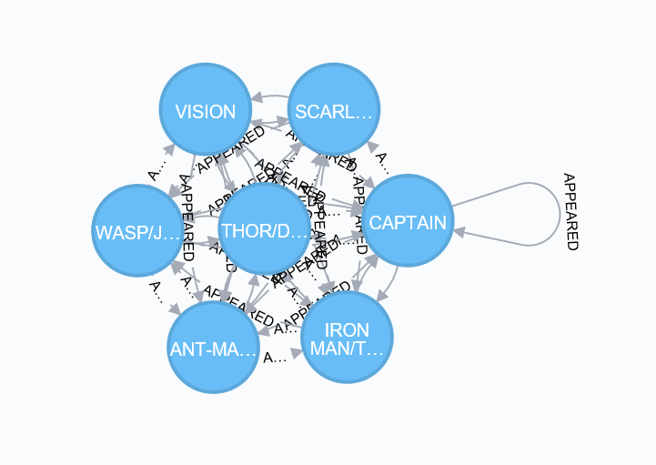

1. 8 members

**Query:**

MATCH (tony:Hero {name:'IRON MAN/TONY STARK'}) -[e:APPEARED]-> (other) <-[f:APPEARED]- (donald:Hero {name:'THOR/DR. DONALD BLAK'})

RETURN tony, donald, other

ORDER BY e.w DESC, f.w DESC

LIMIT 6

**Members:**

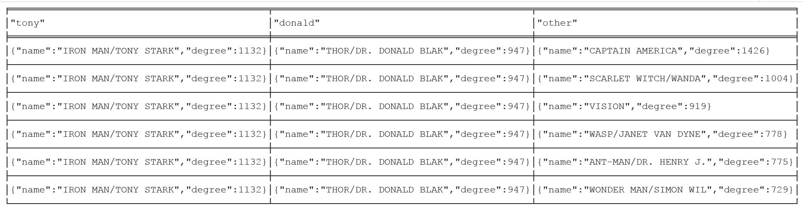

**Graph**: It’s a connected graph.

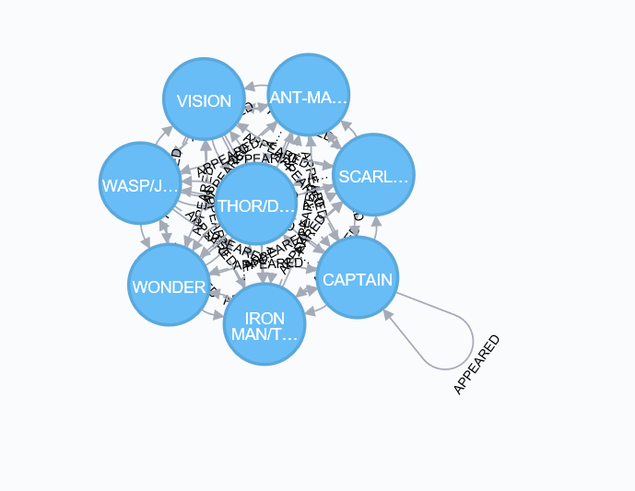

1. 9 members

**Query:**

MATCH (tony:Hero {name:'IRON MAN/TONY STARK'}) -[e:APPEARED]-> (other) <-[f:APPEARED]- (donald:Hero {name:'THOR/DR. DONALD BLAK'})

RETURN tony, donald, other

ORDER BY e.w DESC, f.w DESC

LIMIT 7

**Members**:

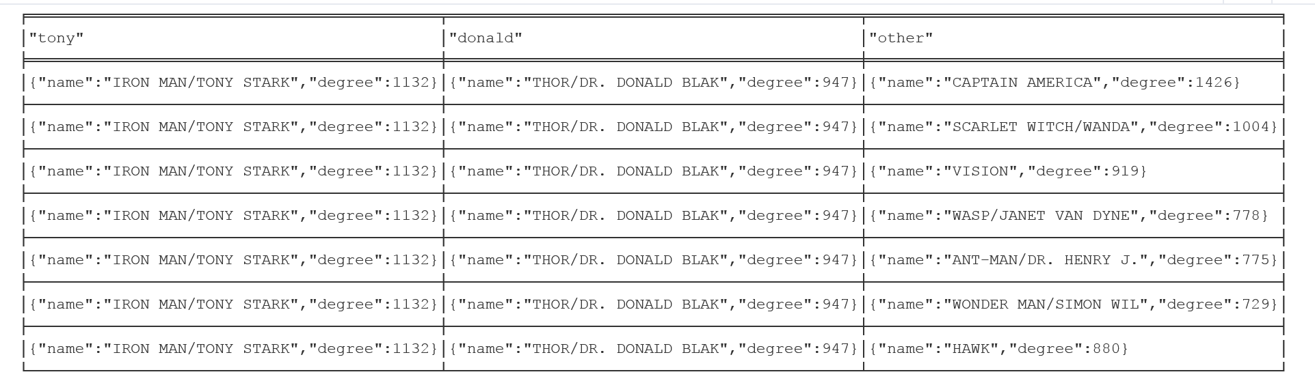

**Graph**: It’s a connected graph.

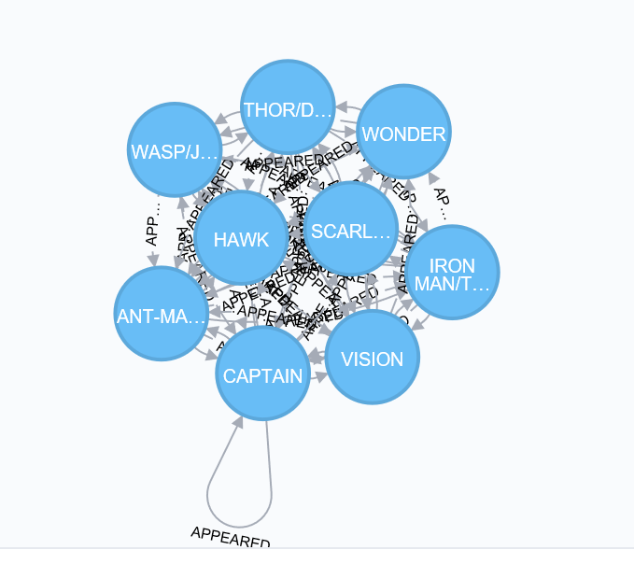

1. 10 members

**Query:**

MATCH (tony:Hero {name:'IRON MAN/TONY STARK'}) -[e:APPEARED]-> (other) <-[f:APPEARED]- (donald:Hero {name:'THOR/DR. DONALD BLAK'})

RETURN tony, donald, other

ORDER BY e.w DESC, f.w DESC

LIMIT 8

**Members:**

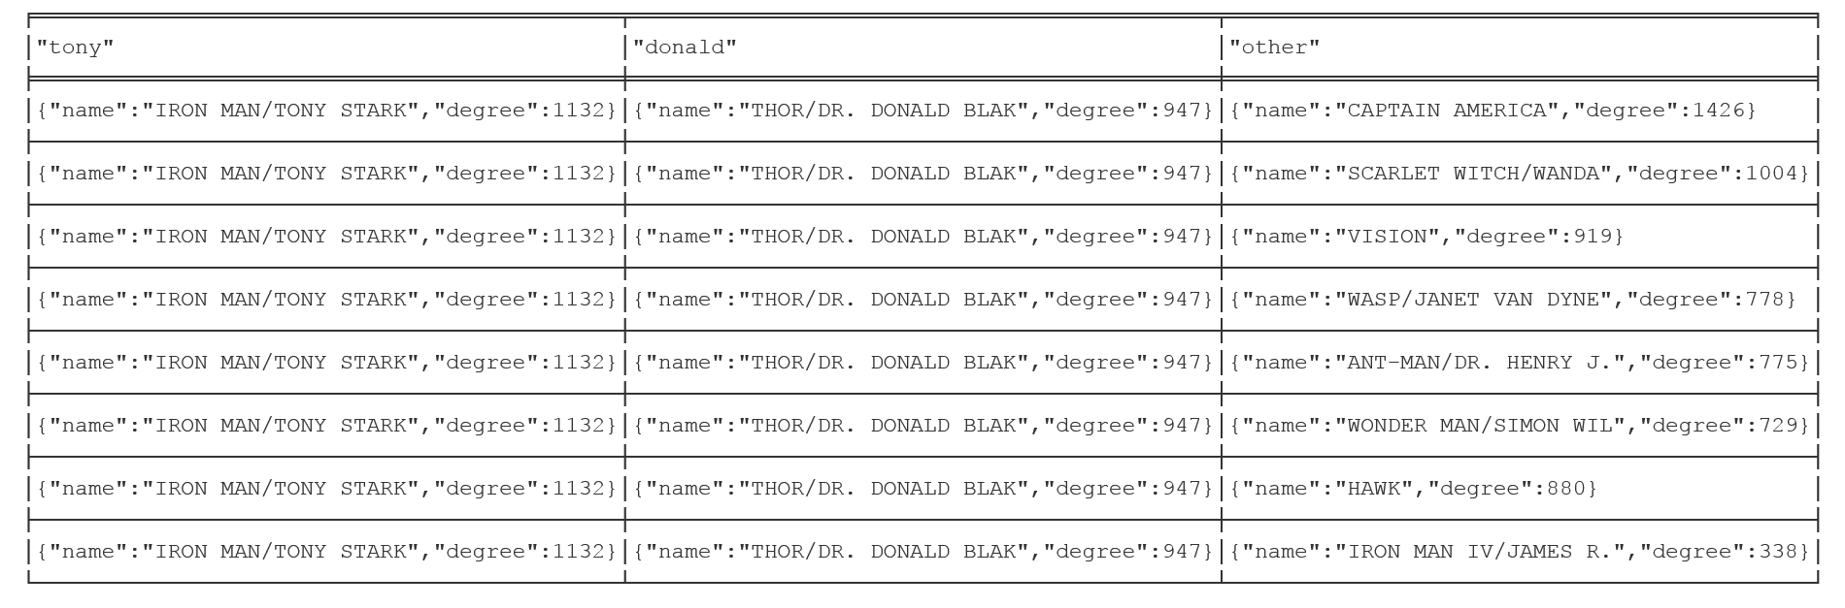

**Graph**: it’s a connected graph.

